Geology 101 Pima Community College Name_________________________
Date ______________

Chapter 13 Lab Activity 1: Deserts and Wind Action Exercise
Arid lands are those where annual evaporation exceeds precipitation. Worldwide, deserts occupy significant areas of the middle latitudes, owing in part to the general circulation of the atmosphere. In this exercise, you will identify a number of landforms associated with deserts.
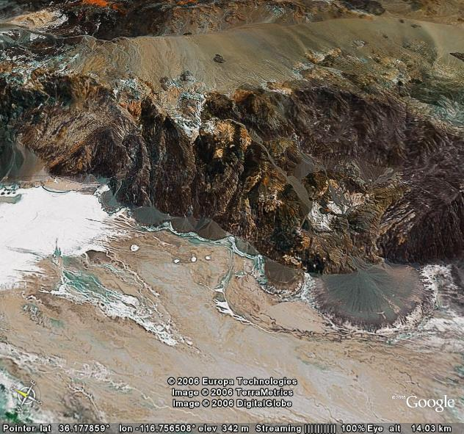
Fig. 1. Google Earth image of desert south of Death Valley National Park, California, USA.
In Google Earth, enter the coordinates below into the query bar:
36.112680 -116.774381 Death Valley National Park, USA.
- Using the coordinates above, scan north and south of this point to locate the following desert landforms and phenomena.
Alluvial Fan | Arroyo | Bajada | Faceted Spur
Fault Block Mountain | Graben | Pediment | Playa
- Mark each landform you find with the ‘Placemark’ tool and label it. Save this labeled image in a Word document. You will upload this document and submit it when you are done with this assignment. When you have found all the landforms and saved images showing them, print each image to submit to your instructor.
- The list of coordinates below will take you to various parts of the world to see examples of different types of sand dunes. Examine each image at the altitude indicated and identify the type(s) of dunes present. The types of dunes include: barchan, transverse, longitudinal, star, and parabolic.
LATITUDE (deg) | LONGITUDE (deg) | ALTITUDE (km) | TYPE of DUNE
32.911034 | -115.045006 | 3
29.518642 | 5.393480 | 40
27.312686 | 7.795855 | 52
27.224491 | 8.644204 | 15
29.958540 | -3.285948 | 13
28.56630 | 41.222551 | 10
21.699600 | 54.930310 | 25
14.064931 | 47.813351 | 10
-24.257854 | 15.094621 | 10
-24.234498 | 14.657788 | 4.00
-20.551653 | -70.05628 | 1.5
Links to Related Sites:
Deserts: Geology & Resources: http://pubs.usgs.gov/gip/deserts/contents/
Desert Landforms & Surface Processes: http://pubs.usgs.gov/of/2004/1007/
Booming Sand: http://www.pbs.org/wgbh/nova/sciencenow/3204/04-recipe.html
More on Booming Sands: http://www.schweich.com/sbdA.html
Sound Producing Sand Avalanches: http://www-personal.umich.edu/~nori/boom/Review-Booming-Sand.pdf

